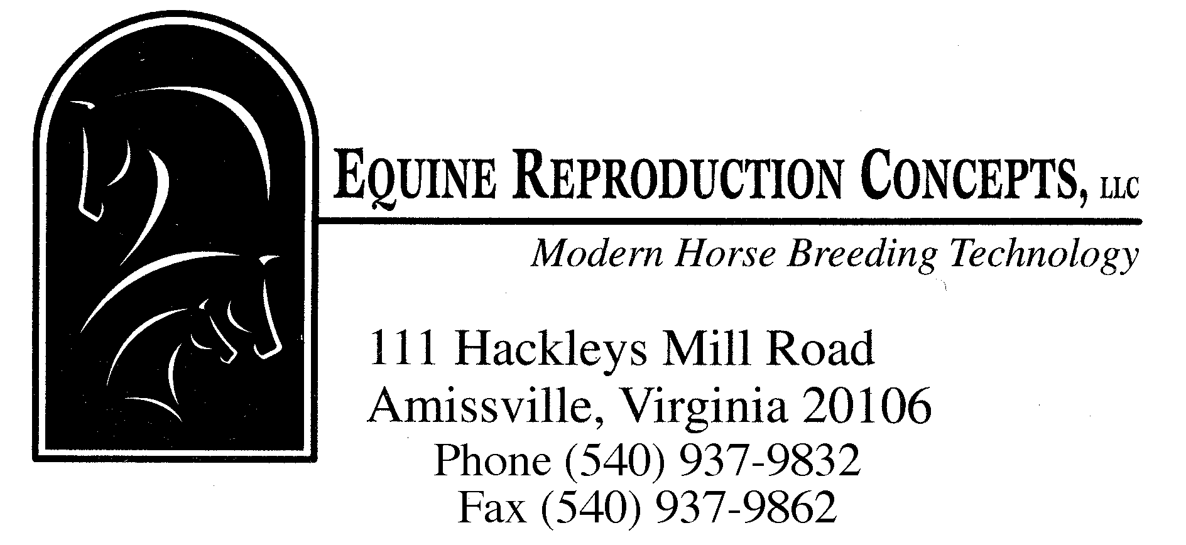
SEMEN FREEZING FEES
(TRADITIONAL COLLECTION)

INITIAL SEMEN FREEZING PROCEDURE $ 780.00
Includes a full stallion reproductive evaluation consisting of two collections and evaluations, cultures, cytology,
morphology and testis palpation.

Includes a test freeze and thaw the following day in two different extenders (Lactose-EDTA & Botucrio extender).

ADDITIONAL FREEZES $ 380.00
For each additional collection and freeze processing necessary
to obtain the total number of breeding doses desired. Additional
test freeze collections may be necessary if the initial freeze fails
to yield acceptable post thaw results (> 30% pms).

BREEDING DOSE (if dose is >30 pms post-thaw) $ 9.00

PREPRINTED FREEZING STRAWS (400 count) ~$ 147.00

FROZEN SEMEN STORAGE
1-7 breeding doses $ 20.00/month
8-100 breeding doses $ 31.00/month
each additional 50 doses $ 12.00/month

BOARDING*
<30 days $ 24.75/day
>30 days $ 20.75/day
*(includes up to 6 flakes hay + 6 lbs pelleted or textured feed. Additional amounts or specialty feeds will be charged at cost.)

ESTIMATES: Costs associated with test freezing
Reproductive evaluation and initial test freeze $ 780.00
Imprinted straws $ 147.00
Additional freezes $ 0.00-760.00
Boarding (1-6 days) $ 24.75-147.00
- - - - - - - - - - - - - - - - - - - - - - - - - - - - - - - - - - - - - - - - - - - - - - - - - - - - - - - - - - - - - - - - - - - - - - - -

TOTAL $ 951.50-1,834.00

Additional costs will be applied based on the number of breeding doses and collections requested by the owner.
Breeding doses $ 9.00/dose
Additional collections $ 380.00
Board $ 24.75/day

Rev.01/21

