FROZEN SEMEN SHIPPING FEES
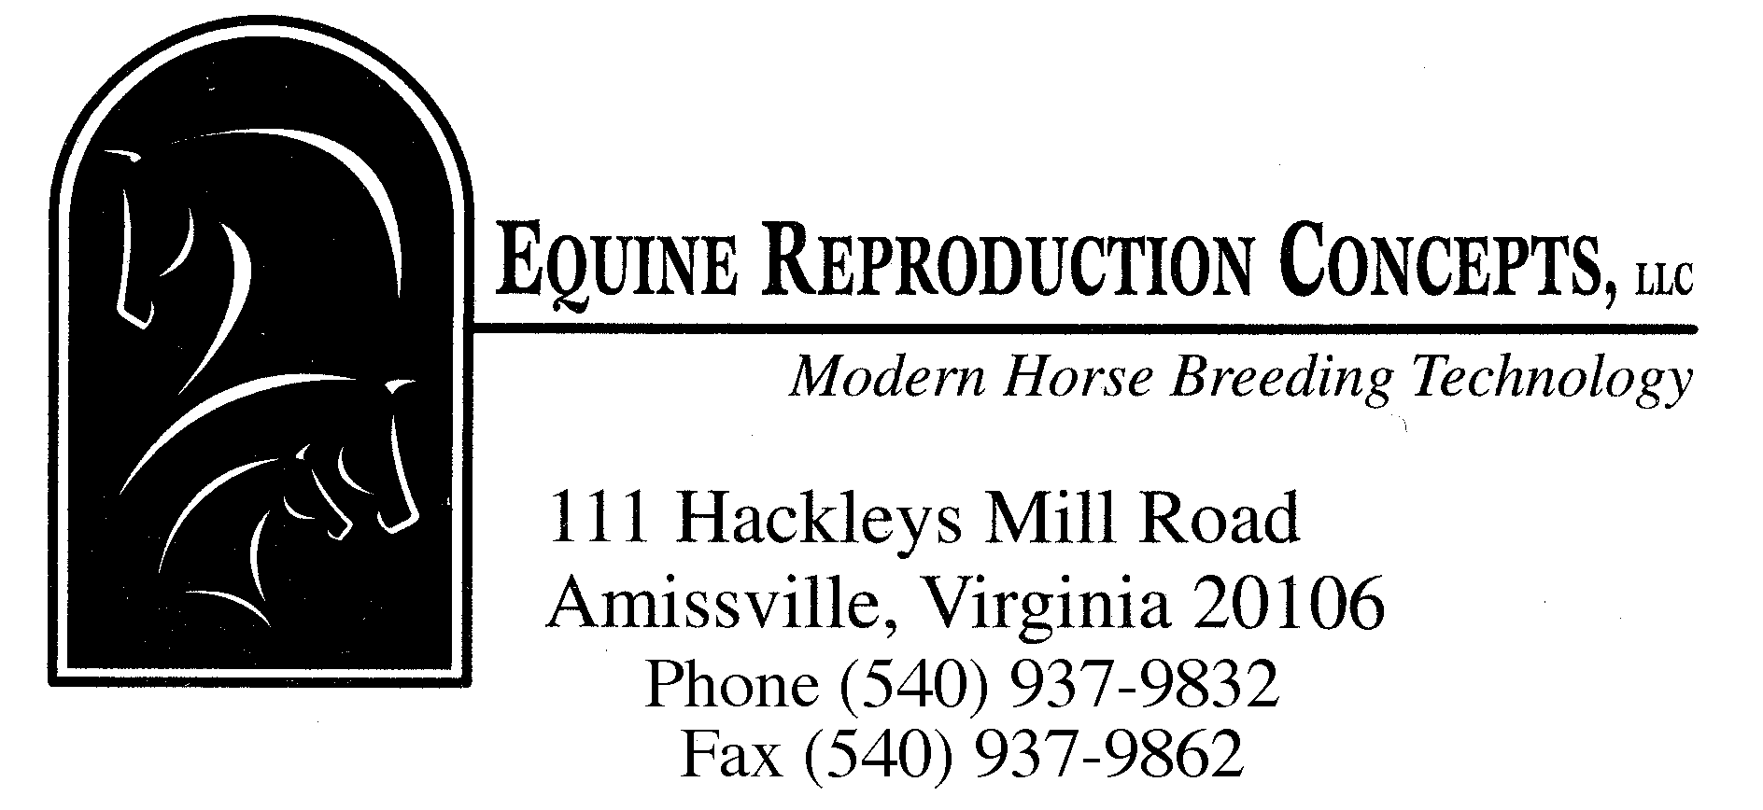

DRY SHIPPER DEPOSIT (credit card kept on file, no charge made) $ 700.00

PROCESSING AND RENTAL FEE FOR FROZEN TRANSPORT $ 95.00
(Includes: Filling of dry shipper with liquid nitrogen and
breeding doses for shipment, and rental for 5 days)

SHIPMENT OF DRY SHIPPER
Priority Overnight service (FEDEX) $~250.00
Standard Overnight service (FEDEX) where available $~200.00
Second day return service (FEDEX) $~100.00
Second day service (FEDEX) outside
continental U.S. $~450.00
Process permits (outside continental U.S.) $~160.00
(Shipment should be insured for $700)

LATE FEE FOR DRY SHIPPER RETURN $ 20.00/day (If not returned within 5 days of shipment)

ESTIMATED TOTAL COST FOR ONE SHIPMENT OF FROZEN SEMEN

~$445.00 (for overnight service + return cost)

Shipping containers are limited so a request for shipment of frozen semen should be made at least 2 weeks before the anticipated breeding date to help assure container availability. If possible, prior arrangements should be made to transfer the semen into a storage tank upon arrival.

Rev. 1/21

