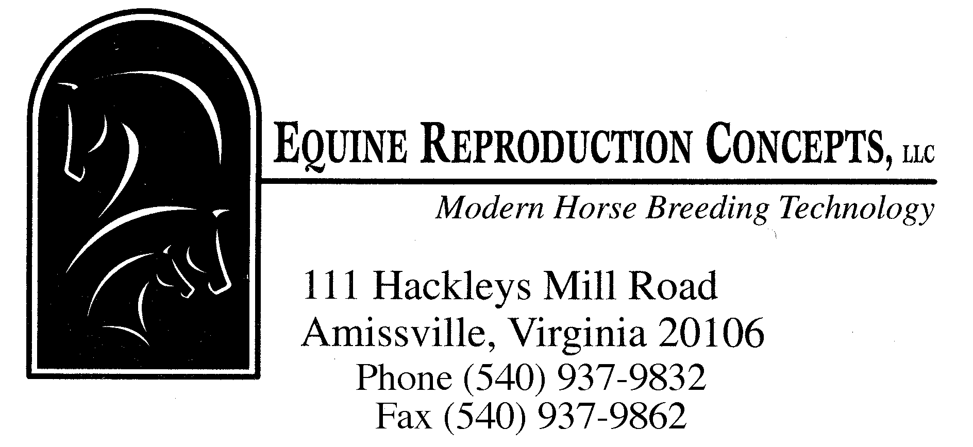 COOLED SEMEN FEES

EQUITAINER DEPOSIT (credit card on file, no charge made) $ 325.00

SEMEN PROCESSING FEE FOR COOLED TRANSPORT
(Includes: evaluation and preparation of one ejaculate
for shipment) $ 155.00

SHIPMENT OF EQUITAINER
Same-day service (AIRLINES) $ ~115.00
Transport to airport $ 90.00
Transport to airport (after 9:00 pm) $ 100.00
Priority Overnight service (FEDEX) $ ~130.00
Priority Overnight to Canada (FEDEX) $ ~360.00
Process permits (Canada) $ ~160.00
Saturday Delivery (FEDEX where available) $ +~30.00
Two-day return service (FEDEX) $ ~75.00
Two-day return service to Canada (FEDEX) $ ~100.00
Rental of Equitainer (5 days, 1 shipment) $ 32.00

LATE FEE FOR EQUITAINER RETURN $ 10.00/day (If not returned within 5 days of shipment)

ESTIMATED TOTAL COST FOR ONE SHIPMENT OF SEMEN
~$392.00* (for next-day service + your return cost)
or ~$467.00* (for same-day service + your return cost)
*Add service call charges for stallions not at ERC.

SERVICE CALL:
(<30 min. from Amissville) $ 48.00
(30-45 min.) $ 58.00
(45-60 min.) $ 68.00
(>1 hr, conditional as to location) $ 78.00+

An initial call should be made on the first day of heat to confirm that breeding will occur during the cycle. All semen orders should be received before 4:00 pm EST, on the day before the anticipated collection/shipping date.

Rev.01/21

