CEM QUARANTINE TESTING
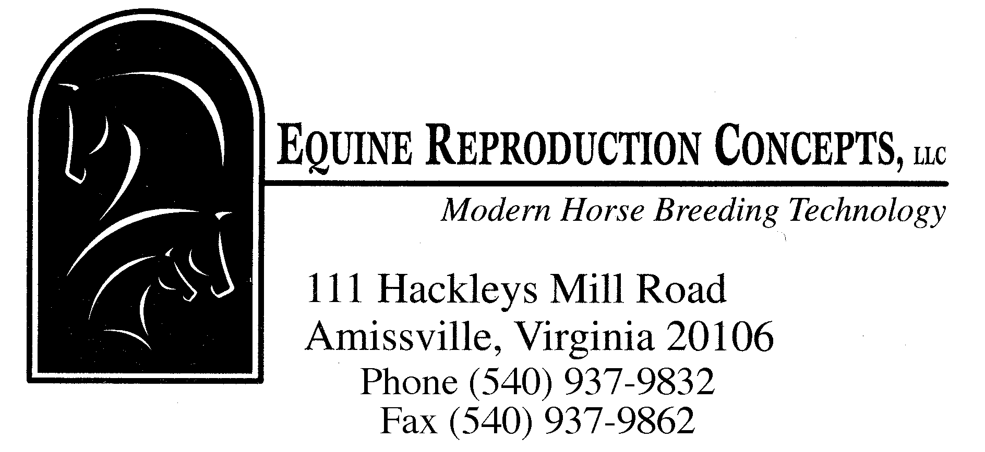

For Non-Pregnant and Pregnant Mares

DURATION OF QUARANTINE 21 - 25 days

QUARANTINE BOARD AND CARE ~$ 777.00
(Includes turnout in isolation paddock = $ 32.00/day)

VETERINARY COSTS ~$ 950.00
Required CEM test procedures include:
(1) Blood test the mare for CEM utilizing a CF test.
(2) Culturing the clitoral fossa and sinuses on Days 1, 4
and 7 of quarantine period.
(3) Culturing the uterine endometrium (in non-pregnant mares)
or cervix (in pregnant mares) on Day 7 of quarantine period.
(4) After culture results confirm negative status, the clitoral
sinusus are manually expressed and flushed with a
cerumalytic compound on Day 1. Beginning on the same
day, the external genitalia, vaginal vestibule, fossa and
clitoral areas are all washed w/ 2% chlorhexidine surgical
scrub, rinsed and coated w/ 0.2% nitrofurazone ointment.
This is done for 5 consecutive days.

LABORATORY FEES ~$ 367.00

Includes shipping and processing of at least 7 culture
samples and 1 blood sample taken from the pregnant or
nonpregnant mare.

STATE FEES (VARIABLE) ~$ 630.00
Includes state veterinarian inspection of procedures
(minimum of 2 times, billed direct to client from VDACS)
State fees are: $45.00/hour and $0.56/mile

If all cultures are negative, the mare can be released from quarantine after the washing and packing procedure is complete. This will be determined by the state veterinarian's office.

APPROXIMATE COST FOR CEM QUARANTINE TESTING
FOR A NON-PREGNANT AND PREGNANT MARE
~ $2,724.00

If interested, please make arrangements with ERC as early as possible to assure stall availability for quarantine.

Rev. 01/21

