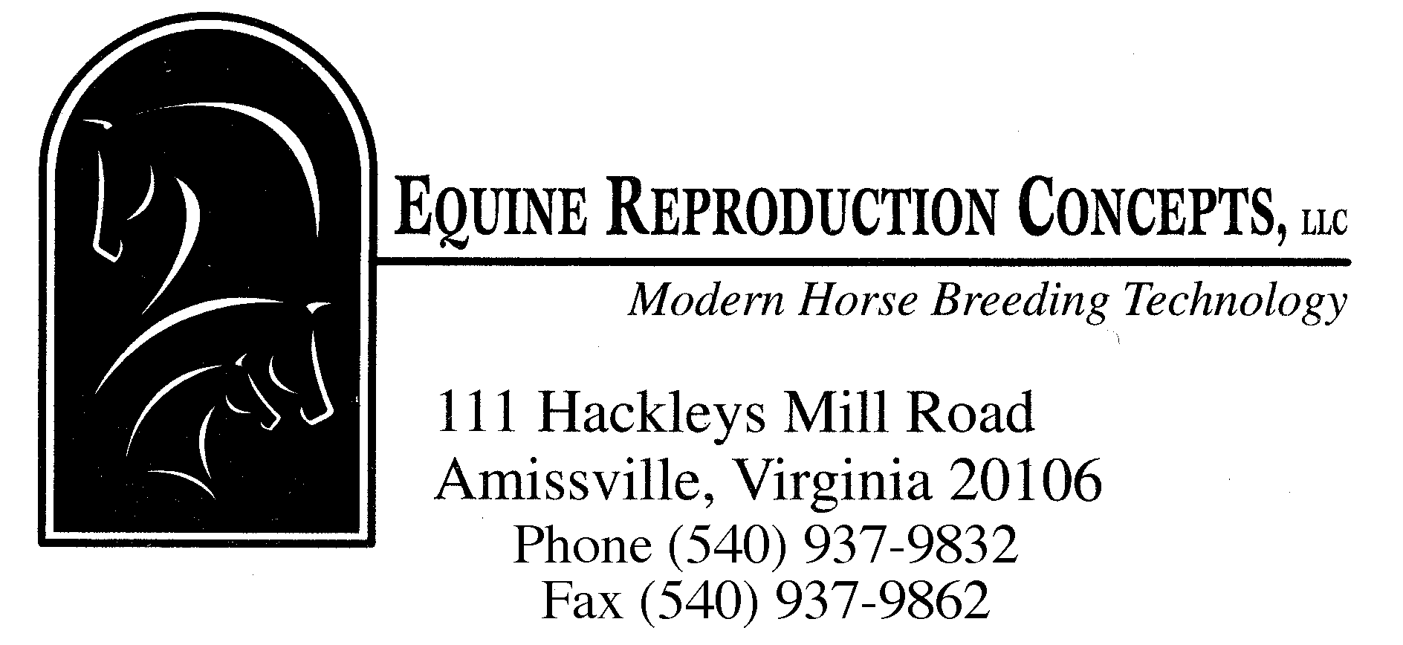

ARTIFICIAL INSEMINATION FEES

ON-FARM
Service call (<30 min. from Amissville) $48.00 (30-45 min) $58.00
(45-60 min) $68.00
(>1 hr, conditional as to location) $78.00+

Artificial insemination (fresh or cooled semen) $49.00/insemination
(frozen) $64.00/insemination

Palpation/Ultrasound $42.00/exam

Collection/evaluation of one ejaculate $135.00

Processing semen for shipment $155.00

AT EQUINE REPRODUCTION CONCEPTS (ERC)
Trailer in/out
Artificial insemination (fresh or cooled semen) $49.00/insemination
(frozen) $64.00/insemination

Palpation/Ultrasound $43.00/exam

Collection/evaluation of one ejaculate $135.00

Processing semen for shipment $155.00

Mare stays at ERC
Mare management service
For fresh/cooled semen $380.00/cycle
(includes unlimited teasing, ultrasound exams and
inseminations for one cycle)

For frozen semen
Option 1(includes unlimited teasing, ultrasound $490.00/cycle
exams and inseminations for one cycle)

Option 2 (includes unlimited teasing, once daily $390.00/cycle
ultrasound exams with inseminations occurring 24
and 40 hours after hCG administration for one cycle)

Boarding* (<30 days ) $24.75/day
(>30 days) $20.75/day
*(includes up to 6 flakes + 6 lbs of pelleted or textured feed per day. Additional amounts or specialty feeds will be charged at cost.
Board fee for mares with foals will remain at $24.50/day after 30 days.)

Additional charges will apply for return of semen shipper to stallion owner, pharmaceuticals, or additional procedures.

Rev. 01/21

